How to Increase You Organization’s Sustainable Palm Oil Use
As conservation organizations dedicated to protecting endangered species impacted by unsustainable palm oil, it’s important that we understand the shared responsibility of the sustainable palm oil industry. Zoos and aquariums inevitably purchase from companies that use palm oil, whether that’s cleaning supplies, animal diets, or even food for visitors. The purpose of this document is to help get any organization started on the path to only sourcing from companies that use sustainable palm oil through the following steps:
Step 1: Taking inventories of all products being used by your organization
Step 2: Figuring out which companies that make the products are committed to sustainable palm oil
Step 3: Replacing unsustainable palm oil companies with sustainable palm oil companies

Step 1
Cheyenne Mountain Zoo’s approach to inventories is to have an inventory list for every department that details what the department purchases, even if you think it might not be related to palm oil. Once a full list is compiled you will need to figure out which company makes the product. Notes are optional but it can be helpful to note how often a product is used to later prioritize any changes that need to be made.
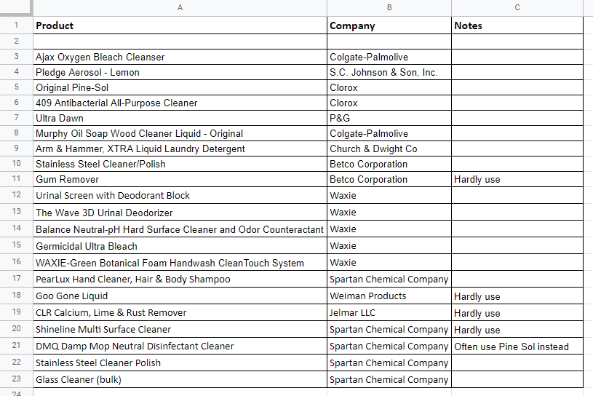

Step 2
Once you have figured out which companies makes the products that your organization purchases, you will then go through the list of companies and note if the company uses palm oil and is a member of the RSPO, if the company uses palm oil and is not a member of the RSPO, or if a company does not use palm oil in any of its products, regardless of the particular product your organization purchases. Use a method to differentiate these categories from one another, for example color coding as shown below.
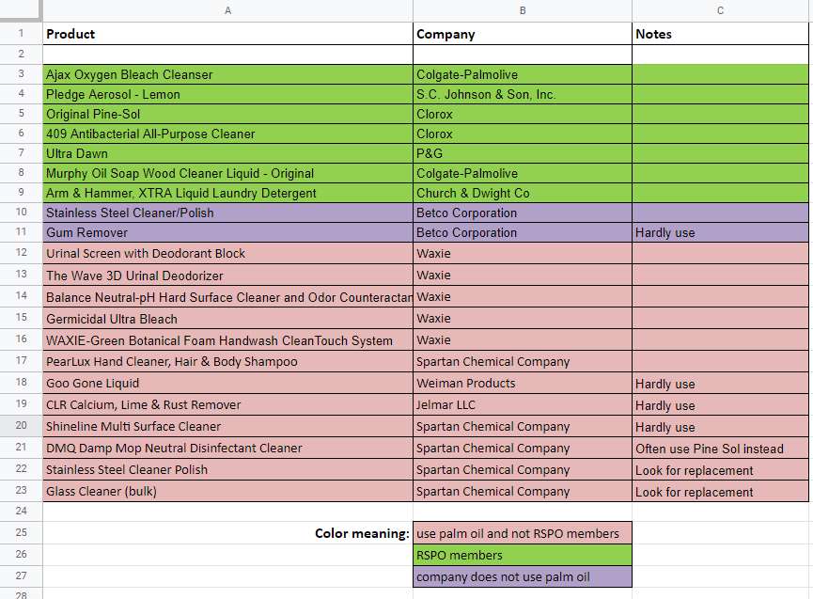

Step 3
The final step is to work towards replacing all companies that use palm oil and are not a member of the RSPO with companies that use palm oil and ARE a member of the RSPO. Alternatively, you can also work on encouraging those companies that use palm oil and are not yet a member of the RSPO to make a commitment to sustainable palm oil by joining the RSPO.
For companies that do not use palm oil at all there is no need to take action. However, we do not encourage seeking out companies that do not use palm oil because we do not believe in boycotting palm oil

Tips
- Even if you think a department does not use products that contain palm oil, you should still create an inventory for two reasons. First, it’s surprising how many products actually contain palm oil or palm oil derivatives that are not obvious. For example, some companies that produce recycled toilet paper use palm oil or its derivatives to “clean” the paper product that is used to create recycled toilet paper. Second, the focus is on the company’s use of palm oil as a whole, not the exact product that is being used. For example, a department might be purchasing crackers that do not contain palm oil from Example Company LLC, so they think they don’t need to create an inventory. However, Example Company, LLC may use palm oil or its derivatives in other products, and by financially supporting that company through the purchase of one specific product, even if it doesn’t contain palm oil, the department is financially supporting unsustainable palm oil.
- Examples of departments or areas and the products they use include:
  - Education or any department that works with children in an education setting. Examples of products used include foods and snacks, craft supplies, and laundry detergent.
  - Visitor / Guest Services or any department that works directly with visitors and members. Examples of products used include hand sanitizer and other gentle disinfectants.
  - Maintenance or any department that works with mechanical equipment or makes repairs. Examples of products used include de-greasers, stainless steel cleaners and rust removers, or paint.
  - Horticulture or any department that maintains the living, botanical grounds. Examples of products used include fertilizers, pesticide and herbicides, and soil mixes.
  - Cleaning or any department that maintains the sanitation of facilities. Examples of products used include liquid soaps and cleaners, bleach, and deodorizers.
  - Animal or any department that cares for animals. Examples of products used include animal diets and food rewards, dish soaps, and animal safe cleaners.
  - Security / First Responders or any department that interacts with the employees or visitors in case of urgent care. Examples of products used include bandages, cold / hot packs, and hydrocortisone creams.
  - Food services or any department that handles food and drink vending. Examples of products used include Coke or Pepsi and popcorn. It is also common for zoos and aquariums to outsource their food and drink vending to a third party company. In the instance of an organization using a third party company we recommend encouraging the third party to become familiar with palm oil and the Roundtable on Sustainable Palm Oil. We also encourage working with the third party to create an inventory and reviewing it with them.
  - Vet or a department that is involved with the veterinary care of animals. As mentioned before products that are necessary for the health of animals should not be altered. An example of a product used in a veterinary setting that can potentially be ensured as sustainable would be cleaning products.
- It is important to look at how commonly the products are being used to prioritize how you will remove the support of unsustainable palm oil from your supply chain. For example, if there is a product that a department purchases frequently that is considered unsustainable it is important to resolve that purchase before resolving the purchase of a product that is used infrequently.
- Any product necessary for the health of an animal should not be altered. Medications and vitamins can include palm oil or derivatives but are necessary to maintain animal welfare and should not be tampered with.
- Understand that getting a company to join the Roundtable on Sustainable Palm Oil (RSPO) is a long process.
- When finding products / companies that need to be replaced with companies that are committed to sustainable palm oil, it is important to work with the department on needs and budget.
- Cheyenne Mountain Zoo believes that all companies that use palm oil or its derivatives should be members of the RSPO and subject to the RSPO’s strict standards and auditing process. Some companies are not a member of the RSPO but say that they are sourcing RSPO certified palm oil for their products. In this instance, Cheyenne Mountain Zoo believes that these non-RSPO member companies should be encouraged to join the RSPO. However, if zoos and / or aquariums must purchase from non-RSPO member companies they should continue to verify that the companies are at least sourcing RSPO certified sustainable palm oil.

